**How to get your OpenAI API Key**

There is an amazing video <https://www.youtube.com/watch?v=SzPE_AE0eEo> on how to get your OpenAI API key. Alternatively, please refer to the step-by-step guide below.

1.Navigate to <https://platform.openai.com/docs/overview>

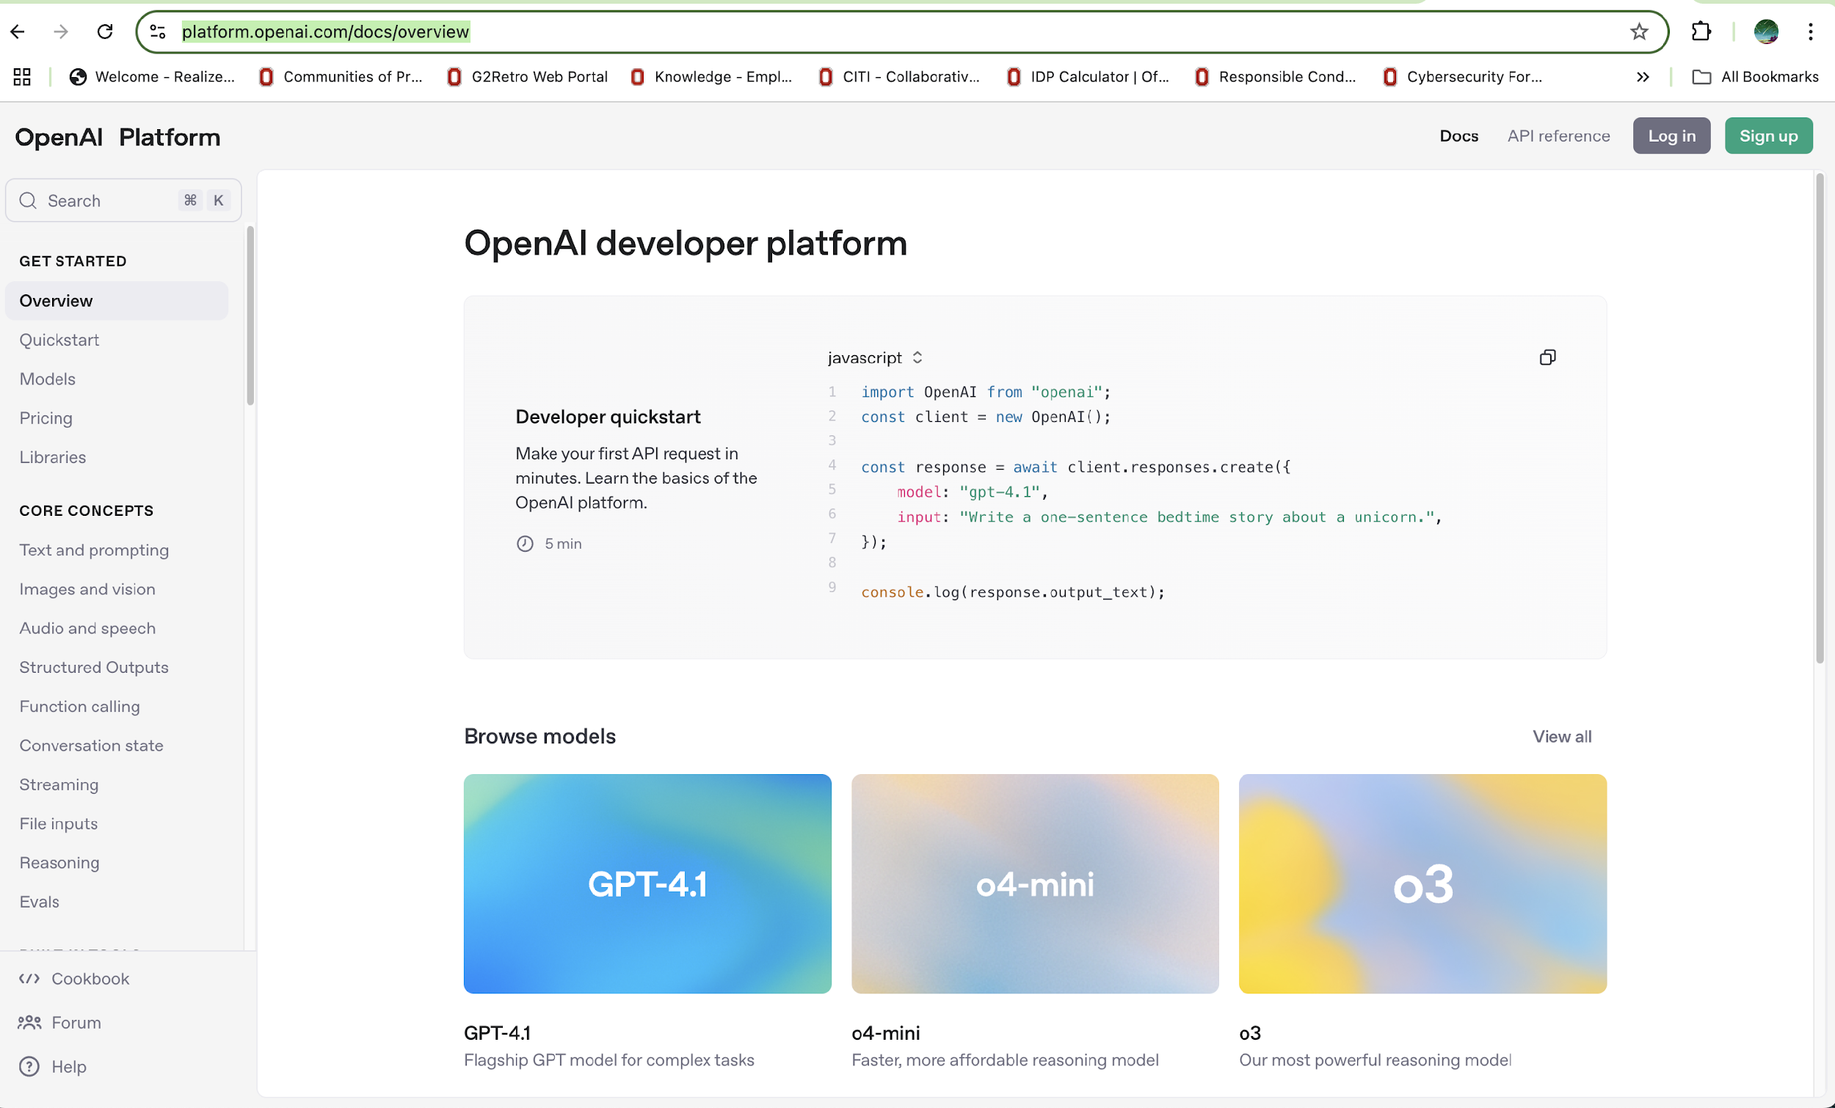

2.Click the **Sign-up** button, and you will see the page below.

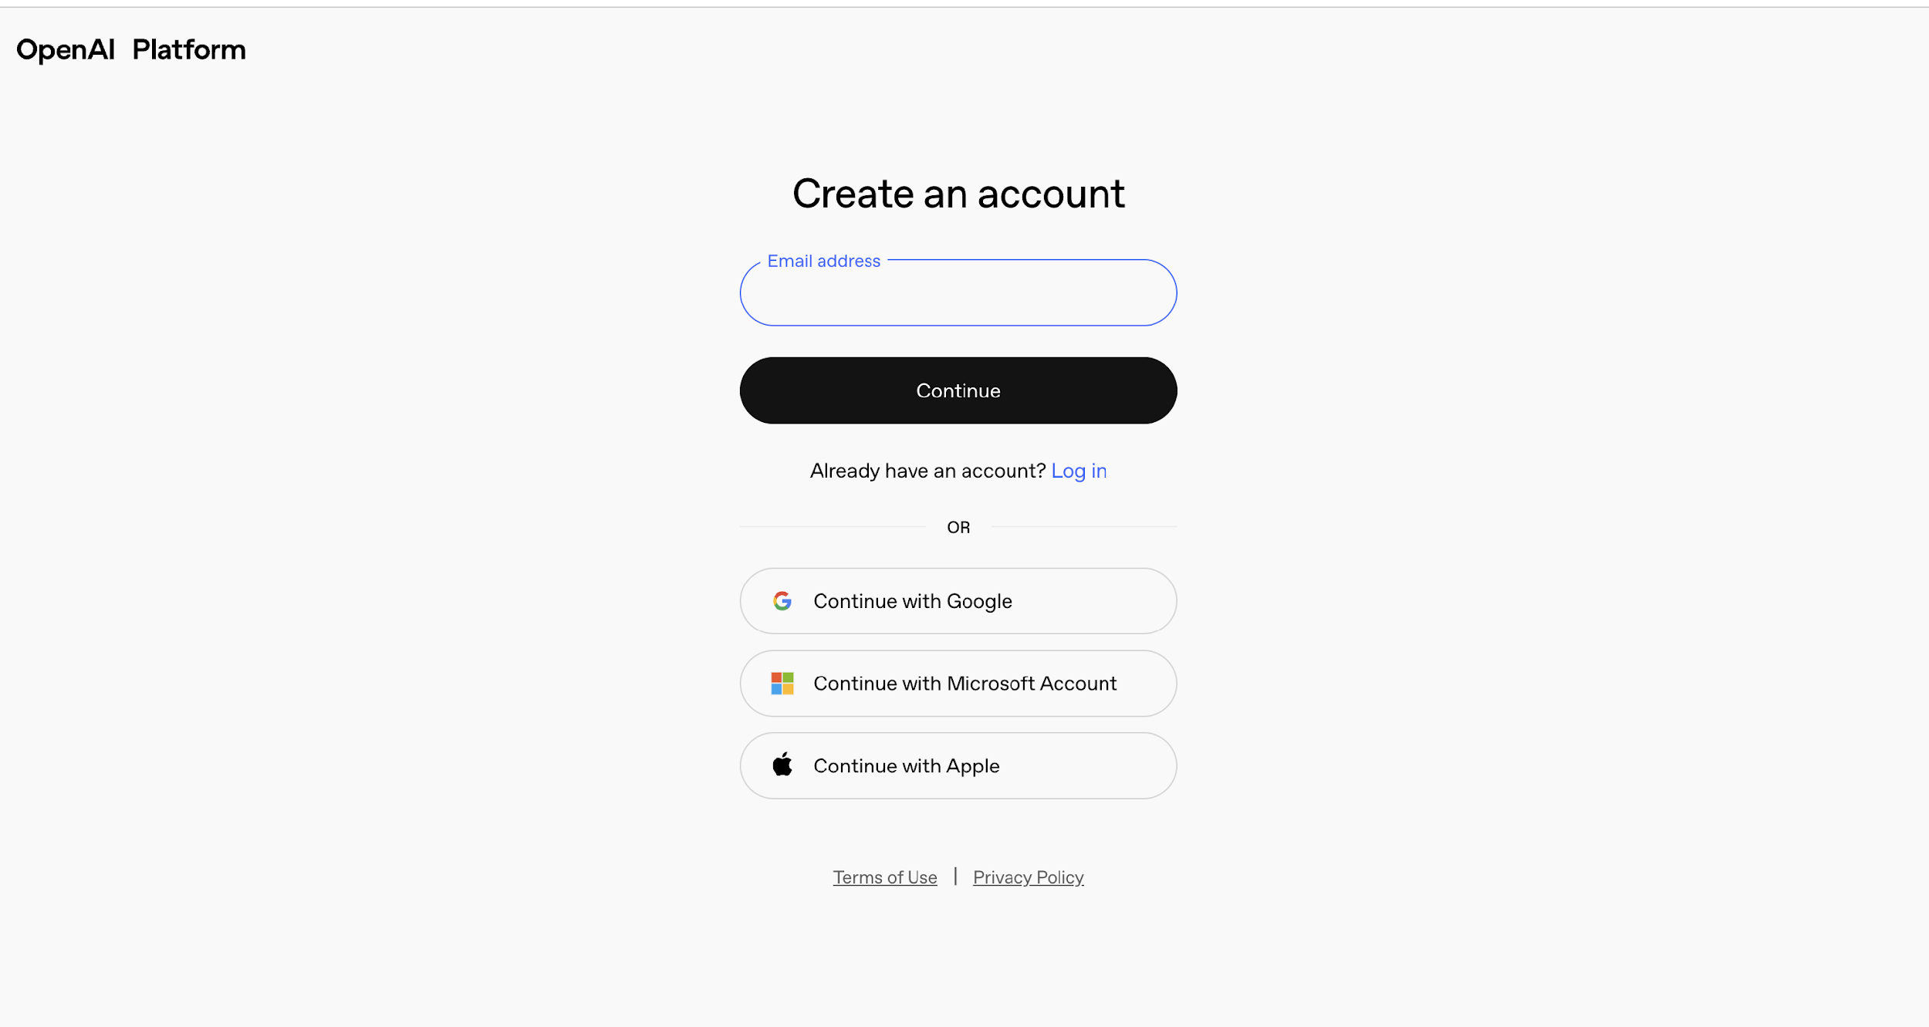

3. After you enter your email address, you will see the page below. Please set a password that is at least 12 characters long, then click **Continue.**

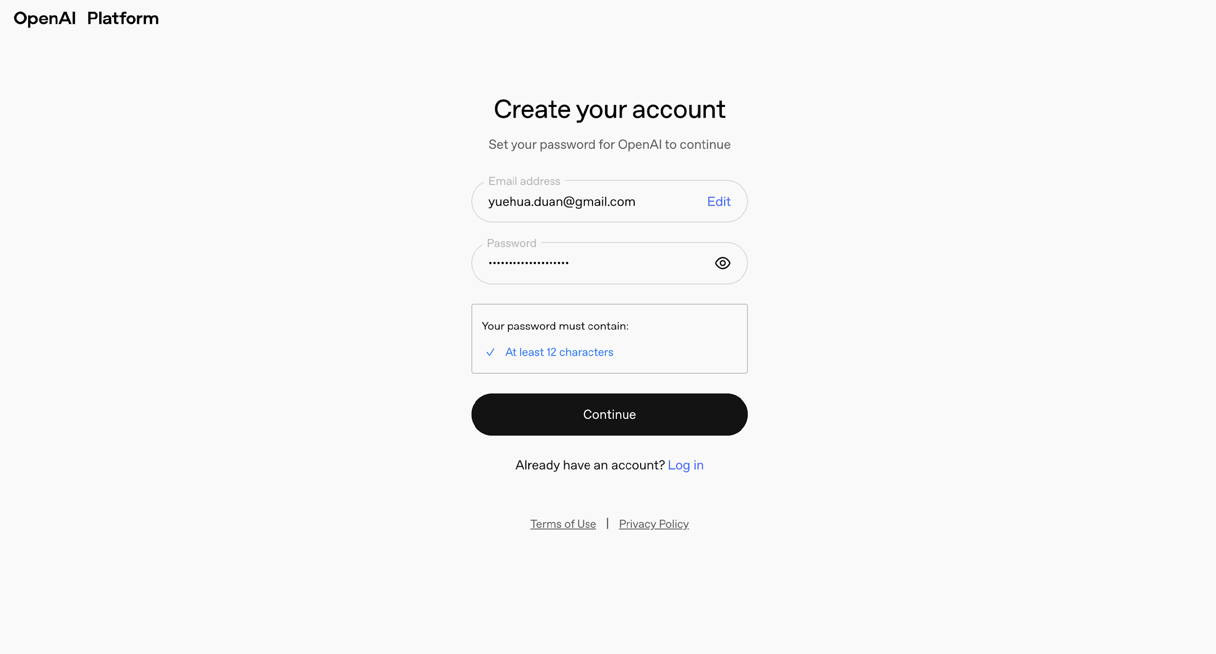

4. Next, you will see a page asking you to verify your email and enter your name and date of birth. After that, you will see the page below. Please enter any organization name you like, then select whether you are **very technical, somewhat technical, or non-technical**. Finally, click **Create organization**.

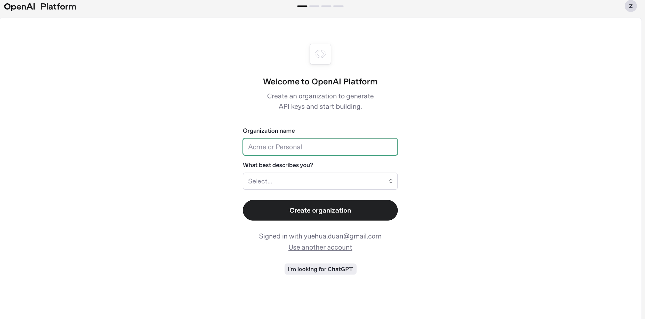

5. Then you will see the page below asking you to invite your team. At this point, please choose "**I’ll invite my team later."**

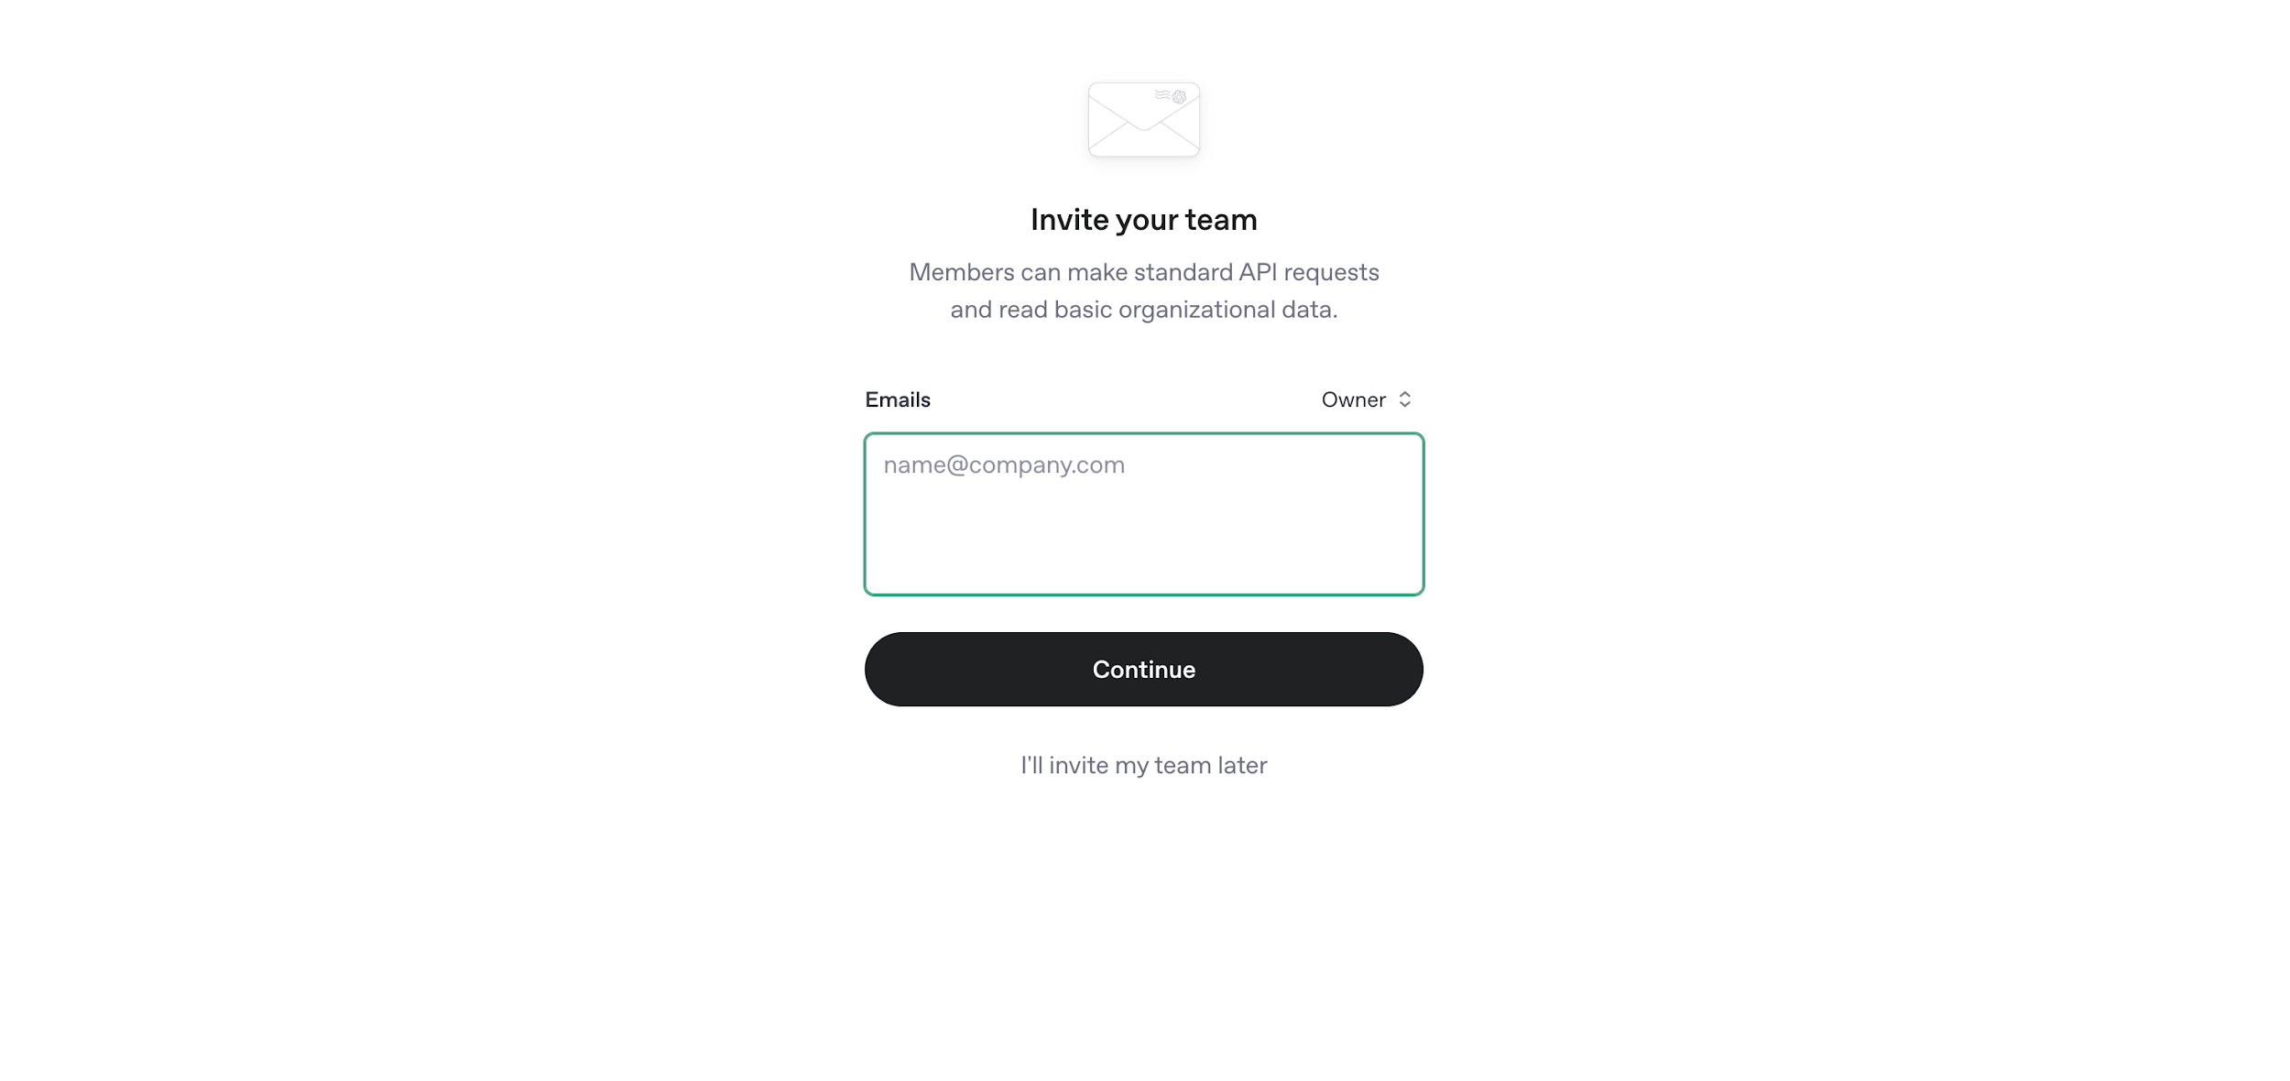

6. Next, you will see the page below. You can use the default API key name or change it according to your preference. Then click **Generate API Key**.

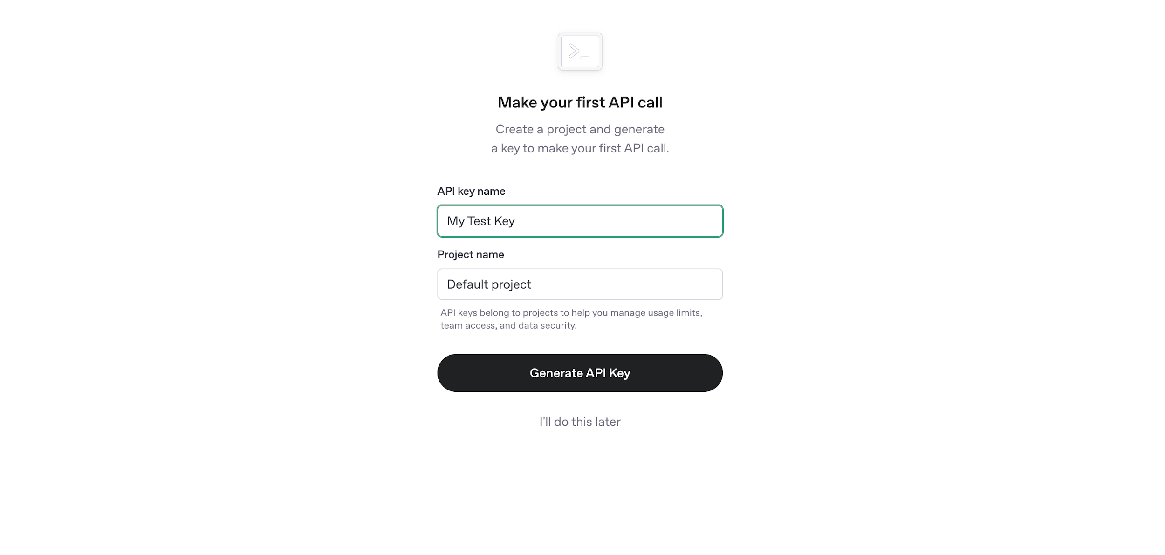

7. You will receive your first API key. Please copy the key and save it in a **safe** place. As it is sensitive information, please do not share it with others. Then click **“Continue”**.

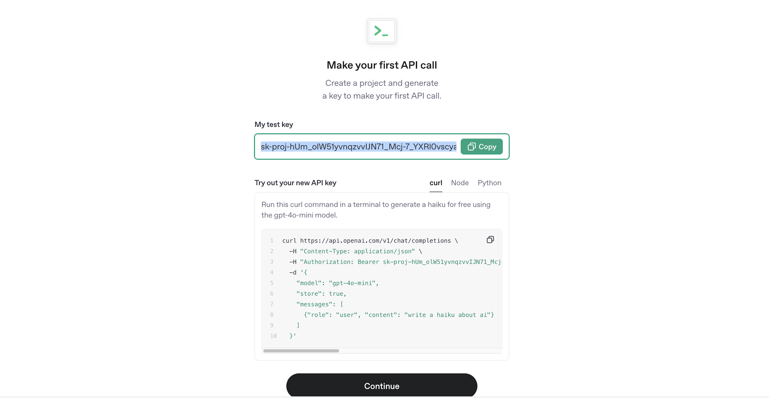

8. Next, you will see the page below. If you prefer to run the code interactively, please plan to purchase some credits. $5 should be sufficient for this workshop, so go ahead and click **“Purchase credits.”** If you prefer to simply listen and learn without running the code interactively, you may skip this step.

